Project Design Phase-II
Data Flow Diagram & User Stories

Date | 31 January 2025
Team ID
Project Name | Automating Data Import and Relationship Mapping Using Import Sets & Dot Walking
Maximum Marks | 4 Marks

Data Flow Diagrams:
A Data Flow Diagram (DFD) is a traditional visual representation of the information flows within a system. A neat and clear DFD can depict the right amount of the system requirement graphically. It shows how data enters and leaves the system, what changes the information, and where data is stored.

Example: (Simplified)

Example: Automating Data Import and Relationship Mapping Using Import Sets & Dot Walking
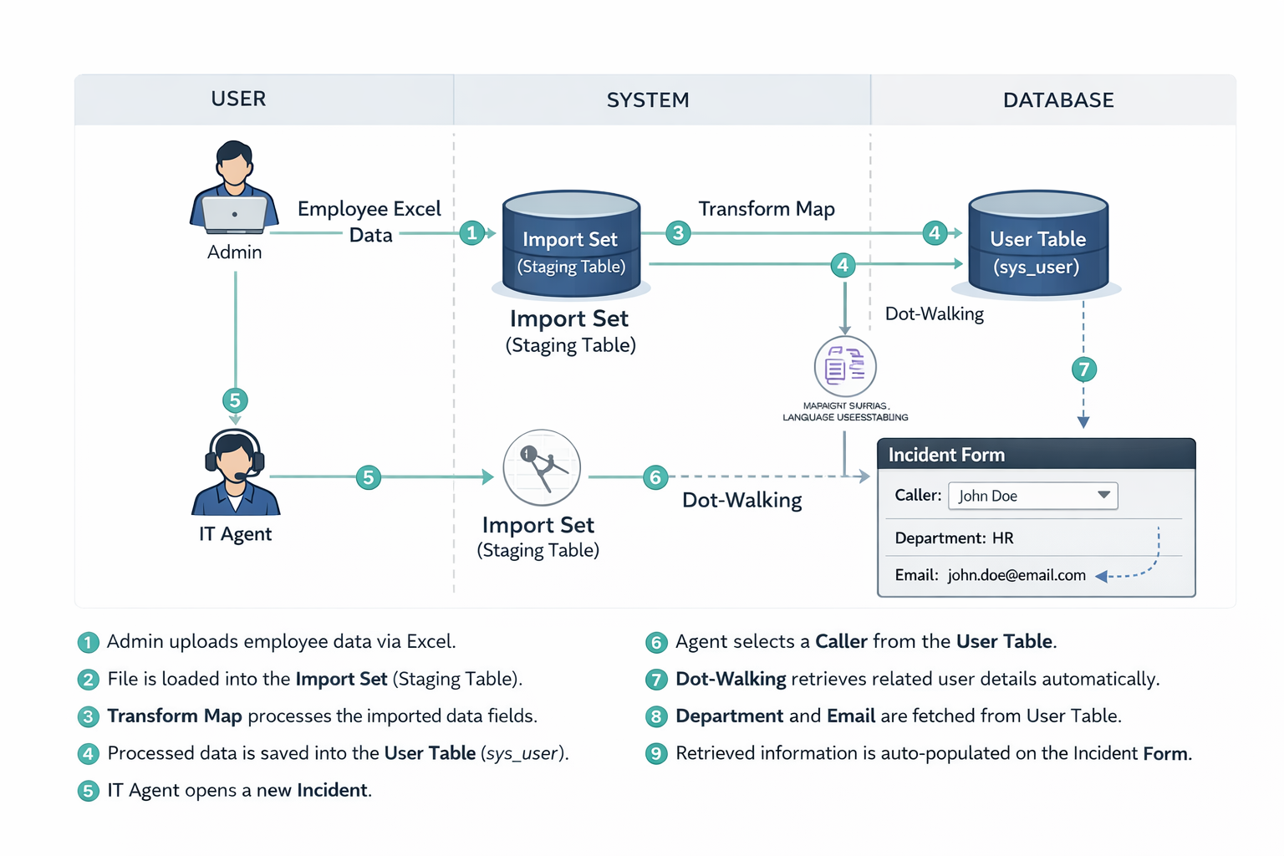

User Stories
Use the below template to list all the user stories for the product.
User Type | Functional Requirement (Epic) | User Story Number | User Story / Task | Acceptance criteria | Priority | Release
System Admin | Data Import | USN-1 | As an Admin, I want to upload an Excel file so that I can bulk-import new employees. | Data is successfully loaded into the staging table. | High | Sprint-1 | High | Sprint-1
System Admin | Data Transformation | USN-2 | As an Admin, I want to map the Excel columns to the User table so the data goes to the right place. | State shows "Inserted" for all rows without errors. | High | Sprint-1
System Admin | Form Configuration | USN-3 | As an Admin, I want to configure the Incident form using dot-walking so it shows Caller details | I can register & access the dashboard with Facebook Login | Low | Sprint-2
IT Agent | Relationship Mapping | USN-4 | As an IT Agent, I want the Department and Email to auto-fill when I select a Caller so I don't have to type it manually. | Form Layout contains Caller.Email and Caller.Department. | Medium | Sprint-1

